***Assignment Name****:* ***Lab2:*** *(****Variables and Constants)***

***Due date:******9/21/2022, by 11:00 am.***

***The grade for the assignment: 20*** *points*

***Purpose:*** *Obtain experience in declaring variables and knowing the difference between variables and constants. Assignment accomplishes course learning objective “analyze problems and design structured solutions”. The assignment also provides preparation for the COSC236 course and enhances skills needed in Information Technology (IT) and Computer Science industries.*

***Skills:*** *The purpose of the assignment is to help you practice the following skills.*

*-Perform Declarations of variables*

*-Ability to display variables and constants as output*

***Knowledge:*** *Become familiar with working in an Integrated Development Environments (IDE), (i.e. Visual Studio CODE) when developing, testing, and debugging computer code.*

***\*\*\*\*\*\*\*\*\*\*\*\*\*\*\*\*\*\*\*\*\*\*\*\*\*\*\*\*\*\*\*\*\*\*\*\*\*\*\*\*\*\*\*\*\*\*\*\*\*\*\*\*\*\*\*\*\*\*\*\*\*\*\*\*\*\*\*\*\*\*\*\*\*\*\*\****

***Place your Name(s) below:***

***Pairs work:*** *Please work in pairs.* ***One student in the team should submit work****. Put* ***your first and last name on the assignment*** *and* ***your partner’s first and last name on the*** *assignment*

***Note(s):***

1. *All programs should be completed within the Visual Studio Code environment. There are guides on blackboard to start you off with Visual Studio Code.*

***Partner 1: Name Blessing Abumere***

***role (did the typing or read and review) _____________________________***

***Partner 2: Name ______________________________________________***

***role (did the typing or read and review)______________________________***

***Please note if one partner did not work on all problems.***

***Submission instructions:*** *All submissions will be done using blackboard.* ***Answers are to be submitted in a Microsoft word document.***

***Task****:*

***Examples:*** *Refer to your notes from class, the Data Representation PowerPoint, C++ Information PowerPoint the Operators PowerPoint, and any available videos (all located in Blackboard).*

***Part1 (20 points):***

1. *Type in the following program. Add a comment at the top to include your name(s) and the date.*

*/\**

*Blessing Abumere*

*9/14/2022*

*\*/*

#include <iostream>

#include <string>

using namespace std;

int main ()

{

//declarations

string name;

//input

cout <<"Enter your first name" << endl;

cin >> name;

//output

cout << "Hello " << name << "! " << endl;

return 0;

}

1. *Compile and run. What does the cin statement do?*
   * The cin in statement pauses the program while the user enters information from the keyboard and stores it in a variable
2. *What does the cout statement do?*
   * The **cout** statement displays information on the screen
3. *Is* ***name*** *a variable or a constant?*
   * **name** is a variable
4. *What data type is* ***name****?*
   * **name** is a **string** data type
5. *Add the following line to the declaration statements:*

*int age;*

*Add the following lines to your program:*

*cout << “Enter your age” << endl;*

*cin >> age;*

*Compile and Run.*

*What data type is age? Describe this data type.*

* **age** is a **int** datatype.
* The **int** datatype stores only wholenumbers**.**

1. *Add a line to display the age on the screen. Compile and Run.*
2. *Add the following line to the declaration statements:*

*float bodyTemp;*

*Add the lines to input and output your body temperature. Compile and run.*

*What data type is bodyTemp? Describe this data type.*

* + Body temp is a float datatype.
  + The **float** datatype stores 7 decimal digits and it is 4bytes

1. *Add the appropriate declaration, input, and output statement for each of the following:*

*Height (hint, use two variables)*

*Weight*

*Sex (hint, use the char data type)*

*Last name*

1. ***SUBMIT your corrected code, and sample of output (Below):***
2. /*
3. Lab 2
4. Blessing Abumere
5. 9/14/2022
6. GEN COMPUTER SCI (COSC175006)-1224
7. */
8. #include <iostream>
9. #include <string>
10. using namespace std;
11. int main ()
12. {
13. //declarations
14. string Fname,Lname;
15. float bodyTemp;
16. char sex;
17. int age,weight,feet,inches; //AGE , weight, and heights
19. //inputs
20. cout << "Enter your first name: ";
21. cin >> Fname;
22. cout << "Enter your last name: ";
23. cin >> Lname;
24. cout << "Enter the first letter of your gender: ";
25. cin >> sex;
26. cout << "Enter your age: ";
27. cin >> age;
28. cout << "Enter your body temperature in Fahrenheit (F): ";
29. cin >> bodyTemp;
30. cout << "Enter your weight in pounds (lb): ";
31. cin >> weight;
32. cout << "Enter your height in feet (ft): ";
33. cin >> feet;
34. cout << "Enter your height in inches (in): ";
35. cin >> inches;
37. //outputs
38. cout << "\nHello " + Fname + " " + Lname + "!" << endl; //First & Last name
39. cout << Fname + "'s body temperature: " << bodyTemp << "F" << endl; //bodytemp
40. cout << Fname + "'s gender: " << sex << endl; //gender
41. cout << Fname + " is " << age << " years old" << endl; //age
42. cout << Fname + "'s height: " << feet << "`" << inches << "\"" << endl;  //height
43. cout << Fname + "'s weight: " << weight;
44. return 0;
45. }

***\*\*\*\*\*\*\*\*\*\*\*\*\*\*\*\*\*\*\*\*\*\*\*\*\*\*\*\*\*\*\*\*\*\*\*\*\*\*\*\*\*\*\*\*\*\*\*\*\*\*\*\*\*\*\*\*\*\*\*\*\*\*\*\*\*\*\*\*\*\*\*\*\*\*\*\*\****

***Criteria for Success****:*

***a****) Be sure to submit your code and output above for each question;* ***Submission of Code and output is required****. (Note: use screenshots or copy and paste).*

*For example, if the assignment was to write a program that displays “Hello World”*

*Your* ***code*** *would be as follows:*

*//Lab1 answer COSC175002*

*#include <iostream>*

*using namespace std;*

*int main()*

*{*

*cout << "Hello, world" << endl;*

*system("pause");*

*} // end of main*

*Your* ***output*** *would be as follows:*

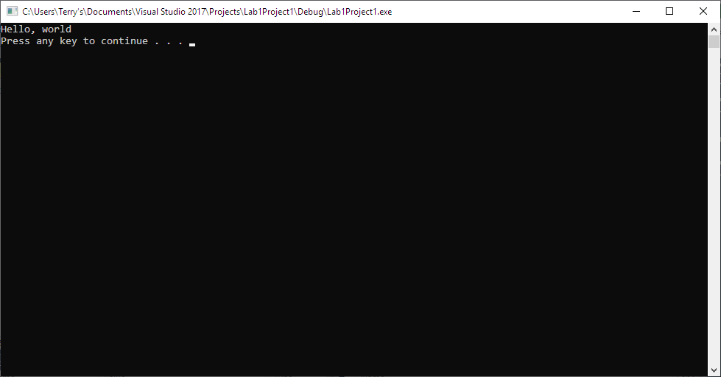

*Note: To avoid additional point deductions; remember to submit both code and output.*

*>>>*

***b)*** *Be sure to show completion of Security Injections by providing Screenshots of (or copy and paste) your Security Injection completion* ***Certificate*** *above****. Do not email me your certificate.***

***c) Late policy:*** *Late submissions will receive a zero grade. Get help during the week so that you can submit it on time.*